**INSIGTHSTREAM: NAVIGATE THE NEWS LANDSCAPE**

**PROJECT TITLE: INSIGTHSTREAM: NAVIGATE THE NEWSLANDSCAPE**

**TEAM LEADER:**  **Hema.u** [**hemaumpathy3@gmail.com**](mailto:hemaumpathy3@gmail.com)

* **TEAM MEMBERS:**
* **MONISHA.A**
* **KALAI SELVI .M**
* **ANITHA.K**
* **INTRODUCTION ABOUT** **INSIGHTSTREAM NAVIGATE THE NEWS LANDSCAPE**

**InsightStream: Navigate the News Landscape** is a modern, responsive web application designed to streamline the way users engage with current events. By leveraging real-time news APIs and intuitive UI components, InsightStream offers a personalized and efficient gateway to global headlines.

This documentation provides a comprehensive overview of the application’s architecture, features, and usage guidelines. Whether you're a developer looking to contribute, a tester validating functionality, or a user exploring its capabilities, this guide will help you understand how InsightStream works and how to make the most of it.

FEATURES OF COOKBOOK:

• Fetches the latest headlines from trusted news APIs.

* Automatically updates content to reflect current global events.
* News is organized into intuitive categories: Politics, Business, Technology, Sports, Entertainment, Health, and more.
* Users can easily switch between topics to explore areas of interest.
* Keyword-based search functionality to find specific articles.
* Filters by category, date, or relevance for refined results.
* Built with **React.js** and **Bootstrap** for a clean, mobile-friendly interface.
* Smooth navigation with minimal loading times and dynamic routing.
* Efficient data fetching using Axios for seamless communication with external news sources.
* Handles errors gracefully with fallback messaging and retry logic.

PROJECT GOALS AND OBJECTIVES:

* **Real-Time News Aggregation**  
  InsightStream fetches up-to-the-minute headlines from trusted news APIs using Axios, ensuring users stay informed with the latest global events across categories like Politics, Technology, Health, and more.
* **Intuitive, Responsive UI**  
  Built with React.js and Bootstrap, the platform offers a sleek, mobile-friendly interface with dynamic routing and smooth navigation for an optimal user experience across all devices.
* **Smart Search & Categorized Browsing**  
  Users can explore news by topic or use keyword-based search and filtering to find relevant articles quickly and efficiently.
* **Robust Architecture & Scalable Design**  
  InsightStream is structured for maintainability and future growth, with optional backend support (Node.js + MongoDB) for features like user authentication and saved articles.
* **Error Handling & User Feedback**  
  The app includes graceful error messaging, loading indicators, and fallback UI to ensure reliability even during API failures or empty search results.
* **Purpose-Driven Development**  
  Created to simplify news consumption, empower informed decision-making, and showcase technical proficiency, InsightStream serves as both a practical tool and a learning platform for modern web development.

PRE-REQUISITES:

Here are the key prerequisites for developing a frontend application using React.js:

✓ Node.js and npm:

Node.js is a powerful JavaScript runtime environment that allows you to run JavaScript code on the local environment. It provides a scalable and efficient platform for building network applications.

Install Node.js and npm on your development machine, as they are required to run JavaScript on the server-side.

* Download: <https://nodejs.org/en/download/>
* Installation instructions:

<https://nodejs.org/en/download/package-manager/>

* React.js:
  + React.js is a popular JavaScript library for building user interfaces. It enables developers to create interactive and reusable UI components, making it easier to build dynamic and responsive web applications.
  + Install React.js, a JavaScript library for building user interfaces.
  + Create a new React app: npx create-react-app my-react-app Replace my-react-app with your preferred project name.
  + Navigate to the project directory: cd my-react-app
  + Running the React App: With the React app created, you can now start the development server and see your React application in action.
  + Start the development server: npm start This command launches the development server, and you can access your React app at [http://localhost:3000](http://localhost:3000/)  in your web browser.
* HTML, CSS, and JavaScript:

Basic knowledge of HTML for creating the structure of your app, CSS for styling, and JavaScript for client-side interactivity is essential.

* Version Control:

Use Git for version control, enabling collaboration and tracking changes throughout the development process

Platforms like GitHub or Bitbucket can host your repository.

* Git: Download and installation instructions can be found at: <https://gitscm.com/downloads>✓ Development Environment:
* Choose a code editor or Integrated Development Environment (IDE) that suits your preferences, such as Visual Studio Code, Sublime Text, or WebStorm.

* Visual Studio Code: Download from <https://code.visualstudio.com/download>
* Sublime Text: Download from <https://www.sublimetext.com/download>
* WebStorm: Download from [https://www.jetbrains.com/webstorm/download/?section=wi ndows](https://www.jetbrains.com/webstorm/download/?section=windows)

TO GET THE APPLICATION PROJECT FROM DRIVE: FOLLOW BELOW STEPS:

✓ Get the code:

Download the code from the drive link given below:

[https://drive.google.com/drive/u/0/folders/1u8PnV_mE0mwKkH](https://drive.google.com/drive/u/0/folders/1u8PnV_mE0mwKkH_CvuNpliZtRLJZMqrO)

[_CvuNpliZtRLJZMqrO](https://drive.google.com/drive/u/0/folders/1u8PnV_mE0mwKkH_CvuNpliZtRLJZMqrO)

INSTALL DEPENDENCIES:

* Navigate into the cloned repository directory and install libraries cd path/to/InsightStream npm install ✓ Start the Development Server:
* To start the development server, execute the following command: npm start Access the App:
* Open your web browser and navigate to [http://localhost:3000](http://localhost:3000/)
* You should see the application's homepage, indicating that the installation and setup were successful.
* You have successfully installed and set up the application on your local machine.
* You can now proceed with further customization, development, and testing as needed.

Project structure:

In this project, we’ve split the files into 3 major folders, Components, Pages and Styles. In the pages folder, we store the files that acts as pages at different URLs in the application. The components folder stores all the files, that returns the small components in the application. All the styling css files will be stored in the styles folder.

**Milestone 1: Project setup and configuration.**

* Installation of required tools:

1. Open the project folder to install necessary tools

In this project, we use:

* + - React Js
    - React Router Dom
    - React Icons
    - Bootstrap/tailwind css
    - Axios
* For further reference, use the following resources **o** <https://react.dev/learn/installation>

* + [https://react-bootstrap-v4.netlify.app/gettingstarted/introduction/](https://react-bootstrap-v4.netlify.app/getting-started/introduction/)

* + <https://axios-http.com/docs/intro>

* + <https://reactrouter.com/en/main/start/tutorial>

**Milestone 2: Project Development**

* Setup the Routing paths

Setup the clear routing paths to access various files in the application.

Ex:

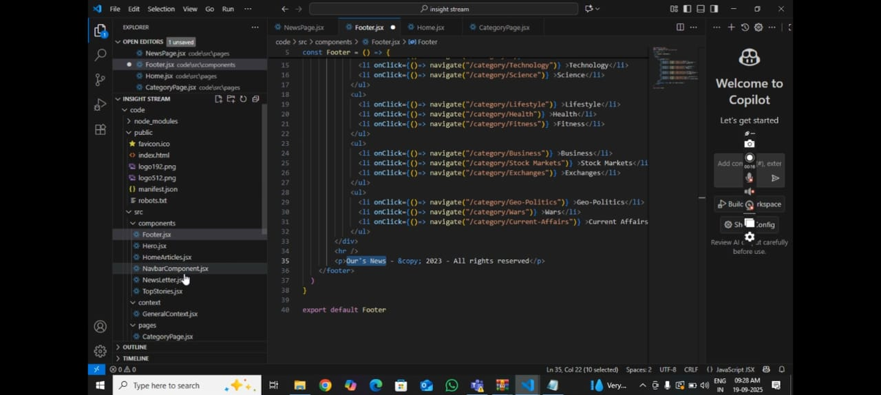

IMAGE CODE

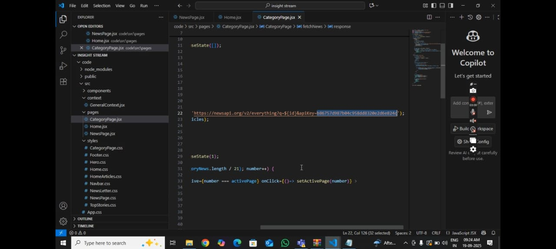

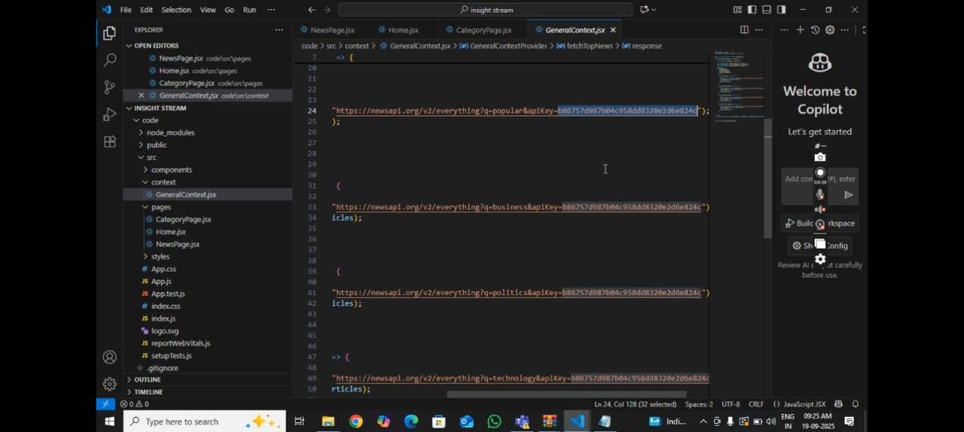

* **Updated Identity** – The new name reflects a clearer, more authentic representation of who we are today.
* **Visual Refresh** – The image was changed to better align with our current style, values, and audience expectations.
* **Brand Consistency** – Both changes help unify our presence across platforms, making us instantly recognizable.
* **Professional Appeal** – The updated look and name enhance credibility and make a stronger impression.
* **User Engagement** – A fresh image and name are more inviting, encouraging people to connect and engage.
* **Future-Ready** – These updates position us for growth, innovation, and new opportunities ahead.

**INSERTED IMAGE:**

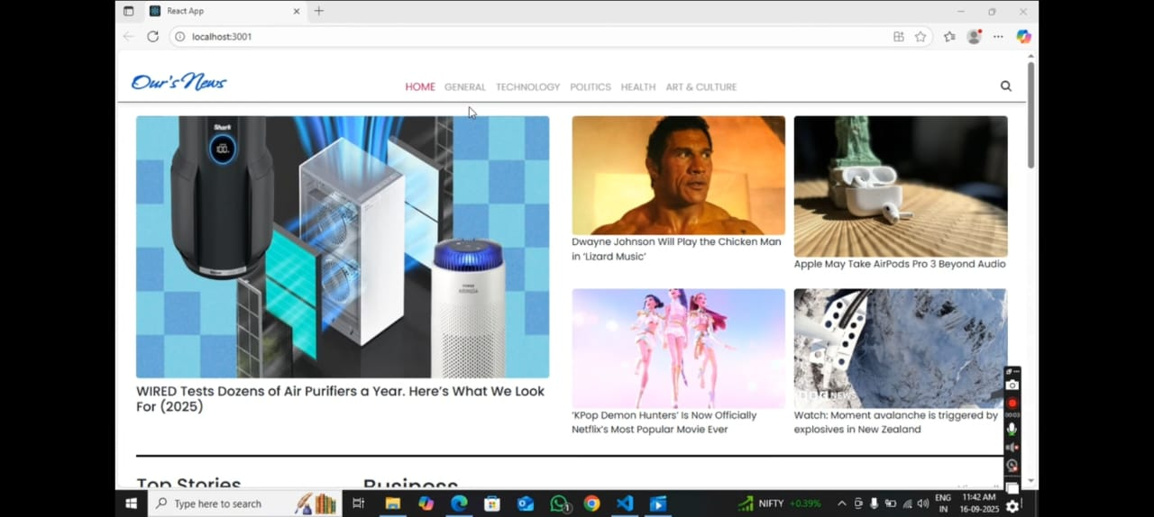

THANK YOU